SQL Notes :

📘 SQL Data Types :
Category | Data Type | Description
Numeric | INT / INTEGER | Whole numbers (e.g., 1, 100, -50).
 | SMALLINT / TINYINT | Smaller range of integers (saves space).
 | BIGINT | Very large integers.
 | DECIMAL(p,s) / NUMERIC(p,s) | Exact fixed precision numbers (best for money). Example: DECIMAL(5,2) → 123.45
 | FLOAT / REAL / DOUBLE | Approximate decimal values (use in scientific data).
Character / String | CHAR(n) | Fixed-length string (pads with spaces if shorter).
 | VARCHAR(n) | Variable-length string (efficient, used for names).
 | TEXT / CLOB | Large text values (paragraphs, documents).
Date & Time | DATE | Stores date (YYYY-MM-DD).
 | TIME | Stores time (HH:MM:SS).
 | DATETIME / TIMESTAMP | Stores both date & time.( YYYY-MM-DD HH:MI:SS) / YYYY-MM-DD HH:MI:SS (with timezone in some DBs)
 | YEAR | Stores only year (YYYY).
Binary | BINARY(n) | Fixed-length binary data.
 | VARBINARY(n) | Variable-length binary data.
 | BLOB | Binary Large Object (images, videos, files).
Boolean | BOOLEAN | Stores TRUE or FALSE (internally 1 or 0).

🗂 Numeric Data Types with Signed/Unsigned
• Signed → Can store both positive and negative values.
• Unsigned → Can store only positive values (0 and above).

Data Type | Signed Range | Unsigned Range | Storage Size
TINYINT | -128 to 127 | 0 to 255 | 1 byte
SMALLINT | -32,768 to 32,767 | 0 to 65,535 | 2 bytes

📘 Advanced SQL Data Types
Category | Data Type | Description
JSON & XML | JSON | Stores structured JSON data (PostgreSQL, MySQL). Can query keys & values.
 | XML | Stores XML documents (SQL Server, Oracle).
UUID / GUID | UUID / GUID | Universally Unique Identifier (used for primary keys instead of auto-increment IDs).
Geospatial | GEOMETRY | Stores geometric data (points, lines, polygons).
 | GEOGRAPHY | Stores earth-based coordinates (lat/long).
Array / Collection | ARRAY | Stores multiple values in a single column (PostgreSQL supports it).
 | MULTISET (Oracle) | Collection of values (like arrays).
Network Types | INET | Stores IP address (IPv4/IPv6) in PostgreSQL.
 | CIDR | Stores network blocks (e.g., 192.168.1.0/24).
 | MACADDR | Stores MAC addresses.
Special Data | ENUM | Stores predefined list of values (e.g., Gender = {‘Male’, ‘Female’, ‘Other’}).
 | SET (MySQL) | Stores multiple predefined values in one column.
Large Object (LOB) | CLOB | Character Large Object (big text, documents).
 | BLOB | Binary Large Object (images, videos, audio).
Money / Currency | MONEY | Stores currency values (with formatting).
Bit & Boolean | BIT(n) | Stores bit-field (e.g., BIT(8) = 10101010).
 | BOOLEAN | Stores TRUE/FALSE values.

CREATE TABLE Products (
ProductID UUID PRIMARY KEY,
Name VARCHAR(100),
Price MONEY,
Category ENUM('Electronics', 'Clothing', 'Food'),
Specs JSON, -- Store specifications as JSON
Location GEOGRAPHY, -- Store latitude & longitude
IPAddress INET, -- Store user IP address
Tags TEXT[], -- Array of tags (PostgreSQL)
Image BLOB -- Store product image
);

📘 Types of SQL Commands

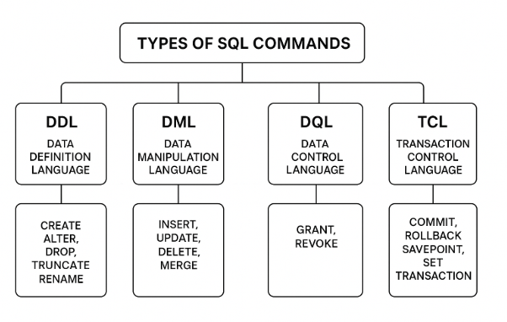

Type | Full Form | Purpose | Examples
DDL | Data Definition Language | Defines or modifies the structure of the database (tables, schemas). | CREATE, ALTER, DROP, TRUNCATE, RENAME
DML | Data Manipulation Language | Used to manipulate (insert, update, delete) the actual data in tables. | INSERT, UPDATE, DELETE, MERGE
DQL | Data Query Language | Used to query (fetch/retrieve) data from the database. | SELECT
DCL | Data Control Language | Controls access and permissions of the database. | GRANT, REVOKE
TCL | Transaction Control Language | Manages transactions in the database (commit/rollback changes). | COMMIT, ROLLBACK, SAVEPOINT, SET TRANSACTION

1. DDL (Data Definition Language)
- Commands to define or modify the structure of database objects.
- CREATE → Create a new table/database.
CREATE TABLE table_name (
column1 datatype,
column2 datatype,
...
);
- ALTER → Modify existing table structure.
ALTER TABLE table_name ADD column_name datatype;
ALTER TABLE table_name MODIFY column_name datatype;
ALTER TABLE table_name DROP column_name;
- DROP → Delete table or database permanently.
DROP TABLE table_name;
DROP DATABASE database_name;
- TRUNCATE → Remove all rows but keep structure.
TRUNCATE TABLE table_name;
- RENAME → Change the name of a table.
RENAME TABLE old_name TO new_name;

2. DML (Data Manipulation Language)
- Commands to manipulate data stored in tables.
- INSERT → Add new records.
INSERT INTO table_name (col1, col2, ...)
VALUES (val1, val2, ...);
- UPDATE → Modify existing records.
UPDATE table_name
SET column1 = value1
WHERE condition;
- DELETE → Remove specific records.
DELETE FROM table_name WHERE condition;
- MERGE (only in some DBs) → Insert/Update together.
MERGE INTO target_table t
USING source_table s
ON (t.id = s.id)
WHEN MATCHED THEN
UPDATE SET t.col1 = s.col1
WHEN NOT MATCHED THEN
INSERT (col1, col2) VALUES (s.col1, s.col2);

3. DQL (Data Query Language)
- Commands to query data.
- SELECT → Retrieve data.
SELECT column1, column2
FROM table_name
WHERE condition;

4. DCL (Data Control Language)
- Commands to control user access.
- GRANT → Provide access rights.
GRANT privilege ON object TO user;
- REVOKE → Remove access rights.
REVOKE privilege ON object FROM user;

5. TCL (Transaction Control Language)
- Commands to manage transactions.
- COMMIT → Save changes permanently.
COMMIT;
- ROLLBACK → Undo changes since last COMMIT.
ROLLBACK;
- SAVEPOINT → Create a checkpoint.
SAVEPOINT savepoint_name;
- SET TRANSACTION → Set transaction properties.
SET TRANSACTION READ WRITE;

Example : 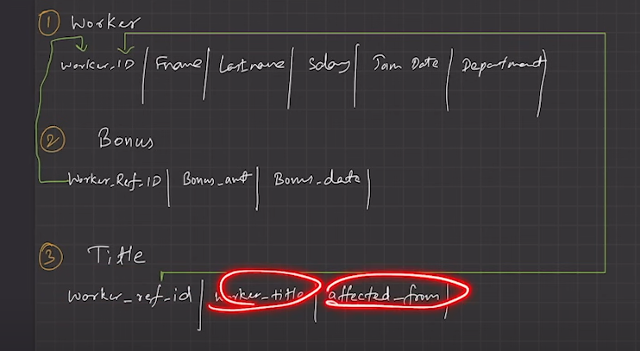
CREATE DATABASE WORKERS;
SHOW DATABASES;
USE WORKERS;

CREATE TABLE WORKER(
worker_id INT NOT NULL PRIMARY KEY AUTO_INCREMENT,
first_Name VARCHAR(255),
last_Name VARCHAR(255),
salary DECIMAL(10,2),
join_date DATETIME,
department VARCHAR(255)
);
INSERT INTO WORKER (first_Name,last_Name,salary,join_date,department)
VALUES
('supriya','shinde',200000,'10-10-24 09:00:00','HR'),
('parth','magar',500000,'10-10-24 10:00:00','Admin'),
('shenha','bhingare',200000,'10-10-25 10:30:00','HR'),
('dhanashri','shinde',100000,'10-10-25 09:00:00','Account'),
('onkar','shinde',500000,'10-10-25 08:00:00','Admin');

SELECT * FROM WORKER;
CREATE TABLE Bonus(
worker_ref_id INT,
bonus_amount INT(10),
bonus_date DATETIME,
FOREIGN KEY(worker_ref_id)
REFERENCES WORKER(worker_id)
ON DELETE CASCADE
);

INSERT INTO Bonus (worker_ref_id,bonus_amount,bonus_date)
VALUES
(1, 5555, '2025-07-07'),
(2, 6666, '2025-07-07'),
(3, 7777, '2025-07-07'),
(4, 8888, '2025-07-07'),
(5, 9999, '2025-07-07');

SELECT * FROM Bonus;

CREATE TABLE Title(
worker_ref_id INT,
worker_title CHAR(25),
affected_from DATETIME,
FOREIGN KEY(worker_ref_id)
REFERENCES WORKER(worker_id)
ON DELETE CASCADE
);

INSERT INTO Title (worker_ref_id,worker_title,affected_from)
VALUE
(1,'HR','2025-05-05'),
(2,'admin','2025-05-05'),
(3,'HR','2025-05-05'),
(4,'Account','2025-05-05');
SELECT * FROM Title;

📘 Some SQL Commands

Show all databases
SHOW DATABASES;

Use a database
USE database_name;

Show all tables in the current database
SHOW TABLES;

Show structure of a table (columns, datatypes, keys, etc.)
DESCRIBE table_name;
Or
DESC table_name;

Print all data from a table
SELECT * FROM table_name;

6. Print specific columns from a table
SELECT column1, column2 FROM table_name;

7. Print only unique values (no duplicates)
SELECT DISTINCT column_name FROM table_name;

8. Print data with conditions (filter rows)
SELECT * FROM table_name WHERE column_name = 'value';
SELECT * FROM table_name WHERE salary > 5000;

9. Print limited number of rows
SELECT * FROM table_name LIMIT 5;

10. Print sorted data :
SELECT * FROM table_name ORDER BY column_name ASC;
SELECT * FROM table_name ORDER BY column_name DESC;
11. Describe table name :
DESC TABLE_NAME;

📘 SQL Conditions

AND / OR / NOT
SELECT * FROM Worker WHERE department = 'HR' AND salary > 100000;
SELECT * FROM Worker WHERE department = 'Admin' OR department = 'HR';
SELECT * FROM Worker WHERE NOT department = 'Account';

BETWEEN
- Used to filter values in a range.
SELECT * FROM Worker WHERE salary BETWEEN 100000 AND 300000;

IN
- Check if a value exists in a list.
SELECT * FROM Worker WHERE department IN ('HR', 'Admin');

LIKE (Pattern Matching)
- % → Matches any sequence of characters
- _ → Matches a single character
SELECT * FROM Worker WHERE first_name LIKE 's%'; -- starts with s (Ex. sum)
SELECT * FROM Worker WHERE last_name LIKE '%e'; -- ends with e (Ex. some)
SELECT * FROM Worker WHERE first_name LIKE '_a%'; -- 2nd char is a (Ex. oma)
SELECT * FROM Worker WHERE last_name LIKE '%pa%'; -- between pa in words (Ex. apan,papaya, papa etc)
SELECT * FROM Worker WHERE last_name LIKE '_pa_'; -- between pa in words (Ex.apan , papaya etc )

IS NULL / IS NOT NULL
- Check for NULL values.
SELECT * FROM Worker WHERE department IS NULL;
SELECT * FROM Worker WHERE department IS NOT NULL;

EXISTS
- Check if a subquery returns rows.
SELECT * FROM Worker w
WHERE EXISTS (SELECT 1 FROM Bonus b WHERE b.worker_ref_id = w.worker_id);

📘 Data Grouping in SQL
👉 Definition:
Data grouping is the process of organizing rows into groups based on column values and then applying aggregate functions (like COUNT, SUM, AVG, MAX, MIN) on each group.

1. GROUP BY
- Groups rows that have the same values in specified column(s).
- Usually used with aggregate functions.
- COUNT
SELECT department, COUNT(*) AS total_workers
FROM Worker
GROUP BY department;
- SUM
SELECT department, SUM(salary) AS total_salary
FROM Worker
GROUP BY department;
- AVG
SELECT department, AVG(salary) AS avg_salary
FROM Worker
GROUP BY department;
- MIN
SELECT department, MIN(salary) AS min_salary
FROM Worker
GROUP BY department;
- MAX
SELECT department, MAX(salary) AS max_salary
FROM Worker
GROUP BY department;

2. Scalar (Single-Row) Functions
👉 Work on individual rows and return a single value.

a) String Functions
- UPPER() → Convert to uppercase
SELECT UPPER(first_name) FROM Worker;
- LOWER() → Convert to lowercase
SELECT LOWER(department) FROM Worker;
- LENGTH() → Length of string
SELECT first_name, LENGTH(first_name) FROM Worker;
- CONCAT() → Join strings
SELECT CONCAT(first_name, ' ', last_name) AS full_name FROM Worker;
- SUBSTRING() → Extract part of string
SELECT SUBSTRING(first_name, 1, 3) FROM Worker;

b) Numeric Functions
- ROUND() → Round to n decimal places
SELECT ROUND(123.456, 2); -- 123.46
- CEIL() → Round up
SELECT CEIL(12.3); -- 13
- FLOOR() → Round down
SELECT FLOOR(12.9); -- 12
- ABS() → Absolute value
SELECT ABS(-20); -- 20
- MOD() → Remainder
SELECT MOD(10, 3); -- 1
Example :

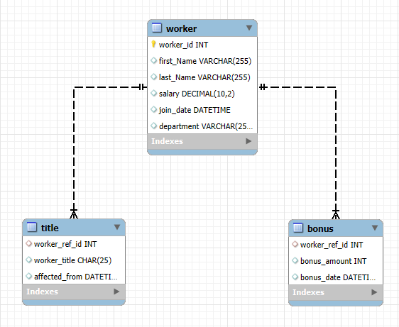

Q 1.find the average of each department

SELECT department , AVG(salary) FROM worker GROUP BY department;

Q 2.find the min salary of HR department

SELECT
department,
MIN(salary) AS min_salary,
CASE
WHEN department = 'HR' THEN MIN(salary)
END AS hr_min_salary
FROM WORKER
GROUP BY department;

✅ Full Template :

SELECT column1, column2, AGGREGATE_FUNCTION(column3) AS alias
FROM table_name
[JOIN other_table ON condition]
[WHERE condition]
[GROUP BY column]
[HAVING condition]
[ORDER BY column ASC|DESC]
[LIMIT number OFFSET number];

🔹 Simple way to remember:
- WHERE → works on individual rows
- HAVING → works on grouped rows (aggregate results)

